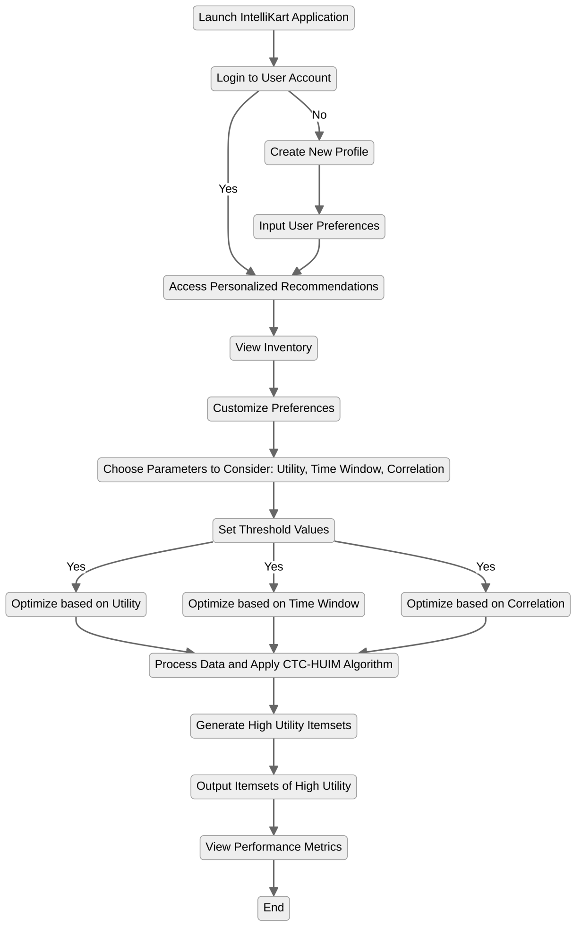

* **User Interaction:** The user launches the IntelliCart app, logs in or creates a new profile, inputs preferences, and accesses personalized recommendations.
* **Optimization Process:** Users customize preferences, select parameters (Utility, Time Window, Correlation), set thresholds, and optimize accordingly.
* **Data Processing & Output:** The system applies the CTC-HUIM algorithm, generates high-utility itemsets, outputs results, and provides performance metrics.

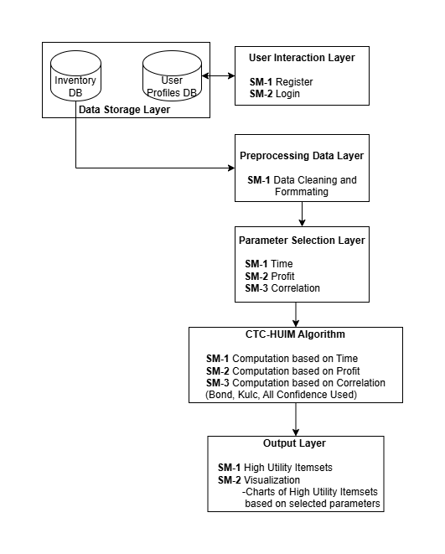

* 1. Data Storage Layer

This layer stores the necessary data, such as inventory information and user profiles.

* 1. User Interaction Layer

This layer allows users to register and log in.

* 1. Preprocessing Data Layer

This layer cleans and formats raw data for processing.

* 1. Parameter Selection Layer

This layer allows users to select parameters (time, profit, correlation) for analysis.

* Time-Based Parameter: Transactions based on timestamps.
* Profit-Based Parameter: Transactions filtered based on profit margins.
* Correlation-Based Parameter: Relationships between items using statistical measures (e.g., Bond, Kulc, All Confidence).
  1. CTC-HUIM Algorithm

This algorithm identifies **high-utility itemsets** based on selected parameters.

* 1. Output Layer

Displays **high-utility itemsets** and visualizations.

* + - High-Utility Itemset Calculation: Identifies the most relevant and profitable item combinations.
    - Visualization Processing Time: Generates charts based on computed results.